**POWER BI**

**ANAMIKA SINGH**

**BANA 6760 E01: DATA VISUALIZATION**

**DATE: FEBRUARY 26, 2021**

**UNIVERSITY OF COLORADO, DENVER**

**Abstract**

The purpose of the assignment is to get familiar with the Power BI by creating reports and dashboard using Startup Expansion Data excel file. Power BI is a powerful tool that easily connects with the data source and helps to visualize and discover what is important. It also facilitates to share the visualization through dashboard which further helps in making business decisions. Five different views are created using Power BI and explained below.

**Analysis and Visualization**

Bar graph is created with state on x axis and marketing spend on y axis. The bar graph also shows market spend by new expansion. This graph represents marketing spend for California is highest and lowest for New Hampshire. Graph also shows that new expansion for marketing spend is much less than old expansion. New expansion is only present in four states.

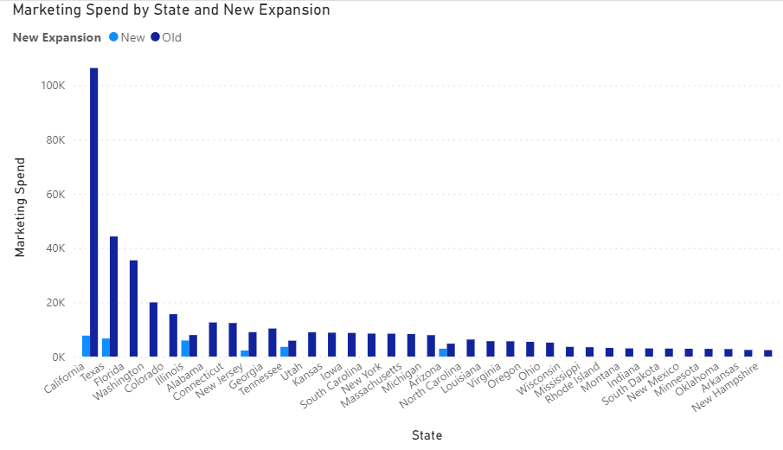

Below is the map of United States. Map visualization represents revenue by state. Color gradient is used to represent the sum of revenue state wise. Lighter color represents low revenue and darker blue color represents high revenue. We can see California has highest revenue, Texas comes second.

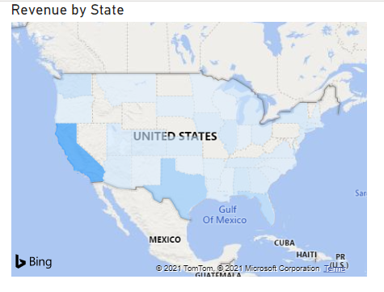

The bar graph below shows revenue by sales region. There are two regions present in the dataset, region 1 and region 2. The graph shows that region 1 gets 2.6M as revenue and region 2 gets 3.3M as revenue which is higher than region 1.

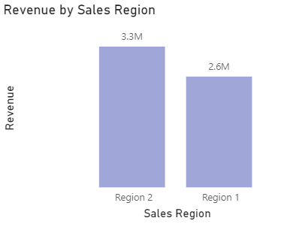

The scatter plot shows revenue on y axis and marketing spend on x axis. The plot represents the relationship between revenue and marketing spend. It is clear from the plot that there is no relationship between revenue and marketing spend. The plot is nowhere near to linear.

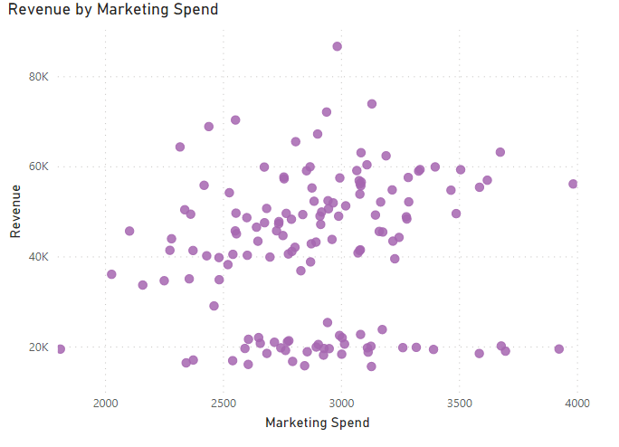

The map visualization represents marketing spend by city on the USA map. Bigger bubble and darker color indicate high marketing spend by city. This interactive map shows the marketing spend, city and state when we hover cursor on the map. We can observe the states and cities where company spend its money on marketing. Also, we can tell that bubbles are densely located in California.

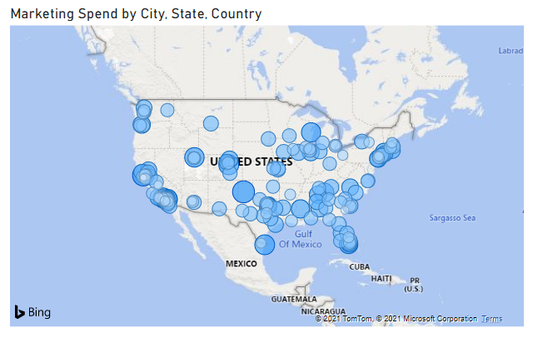

**Conclusion**

Reports and dashboard are created in Power BI by importing Startup expansion data excel file. Creating visualizations in Power BI is pretty straightforward. It was easy to create interactive graphs and maps to draw insights from the dataset. Visualization helped to know that marketing spends and revenue for California is highest and there is a weak relationship between revenue and marketing spend. The company gets higher revenue from region 2.

REFERENCE:

MyOnlineTrainingHub. (2018 February 25). How To Build Power BI Dashboards [Video]. YouTube.

https://www.youtube.com/watch?v=BsXliHbOFDM&t=1748s